ASIC 130 – Design Challenge 1

In this exercise, you will experiment with transistor sizing to see if you can find the optimal delay in a circuit. There are mathematical tools for solving this problem which we will eventually cover in the course; before we do, I want you to experiment to get a feel for it on your own. This is also a good exercise to get you familiar with simulating in Cadence.

Everything is already set up for you; once you’re inside Cadence you can be simulating within minutes. Getting Cadence running may take a bit of effort. There are resources on our website (www.asic.uwaterloo.ca). Feel free to work in groups if you prefer. We’ll discuss the solution at the next session (Feb 22).

You are given a circuit of the following form:

Input: Pulse waveform
Vout
C_{L}
Output: Pulse waveform
Size: 1
Size: s1
Size: s2
Vin
The size of the leftmost inverter is fixed at 300nm / 600nm (the PMOS is twice the size of the NMOS – we will explain why in the next lecture). (By size I really mean width, the only parameter which you as a designer can control.) We will define this as “minimum size”; assume it is impossible to make an inverter any smaller than that. The second and third inverters are sized such that their widths are multiples of 300nm / 600nm.

The load capacitance, C_{L}, is formed by the parasitic capacitances of an inverter 100 times the size of the left-most inverter. You can treat it as an ordinary capacitance to ground. Its actual value (i.e. in Farads) is not important for this exercise.

At steady state, if Vin = 0, Vout = 1.8V. If Vin=1.8V, Vout=0V. When Vin switches, the transition will propagate through the circuit and Vout will eventually switch as well. The propagation delay is defined as the time difference between the midway points between each transition:
1.8
0
0.9
Voltage
Time
Vin
Vout
t_{p}: propagation delay
Your task as a designer is as follows:

Minimize the propagation delay by adjusting sizes s1 and s2 only. They should take values between 1 and 50. They need not be integers, although you will find that the difference between, say, 10 and 10.5 is minimal.

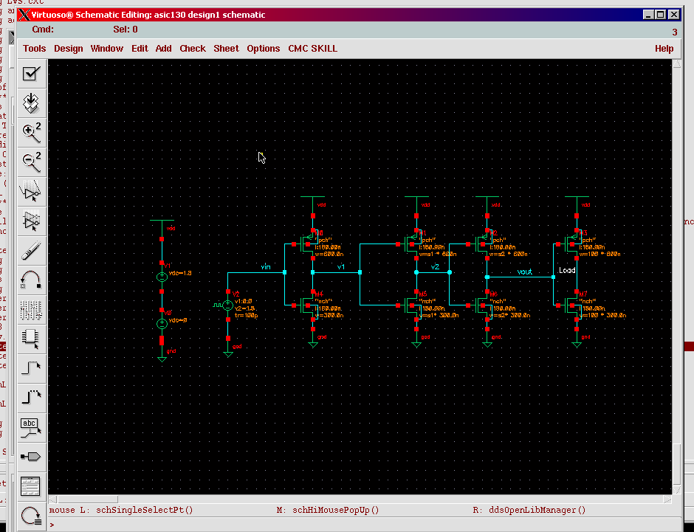

How to proceed:

If you know the uwasic password:
- Log in as uwasic@blade1.vlsi.
- cd asic130
- startCds –t cmosp18. this should start Cadence.
Or, if you have an account on the SunEE machines:
      - Log in (password is your student number by default) to harshrealm
      - cd /home/pteehan/asic130
      - startCds –t cmosp18
Let me know if that doesn’t work for you.

- Open the library manager (F6). You should see a library called asic130 with one cell inside called design1.
- Open the schematic view for the cell design1.
- From the schematic editor: tools->analog environment
- From the analog environment: setup->simulator/directory/host
  - Select “SpectreS” as your simulator.
- Go to session-> load state
  - Choose the state titled “Design1”
This is a previous simulation run I already set up for you. In the lower left corner are your design variables s1 and s2; you can change the values and then re-run the simulation by clicking simulation->Run. Two delays will be calculated for you: tp1 and tp2. One is for the high-to-low transition, and the other for the low-to-high. They will appear on the ‘outputs’ pane of the Analog Design Environment. Their values will probably be different; again, we will discuss why in the next lecture.

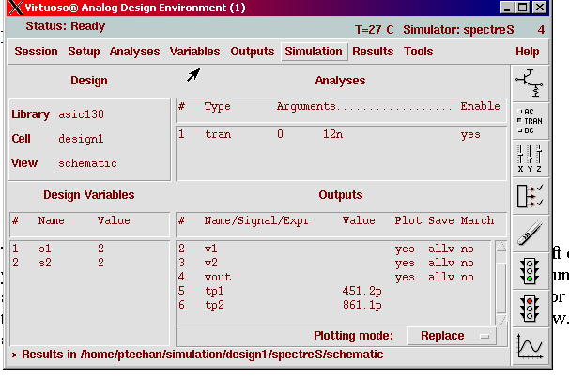

Basically you can tweak s1 and s2, run the simulation, look at the values of the outputs that appear, and repeat. It is possible to get the average delay [(tp1 + tp2)/2] less than 250 ps. In fact the minimum may be quite a bit lower than that. I haven’t worked it out (that’s up to you).

When you run the simulation a waveform window will appear as well. You are encouraged to look at how the values you choose affect the waveforms.

Do not overwrite the schematic or saved simulation state. Feel free to duplicate it and play around with a copied version.

E-mail me with questions, and tell me if you manage to beat 250ps. Prizes for the winners on Feb 22.

- Paul: pteehan@engmail

